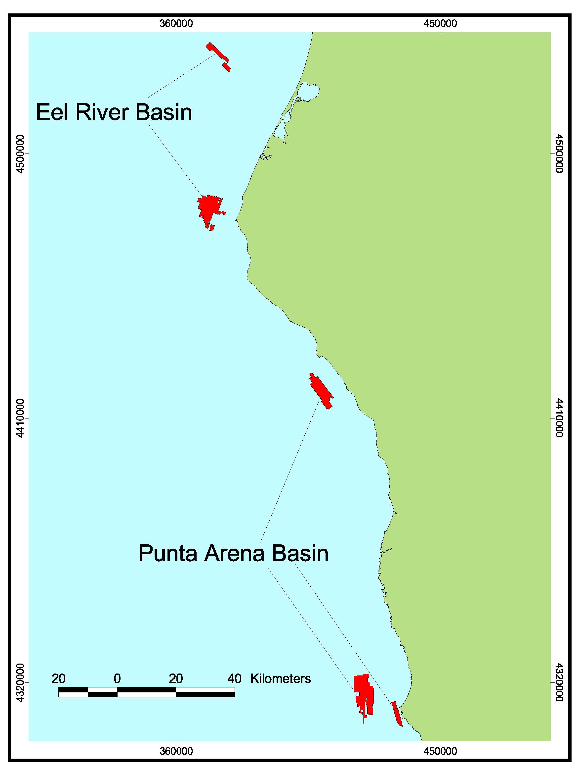
Footprint Map for Northern Region B. All regions included in this volume were surveyed by industry using sidescan sonar imagery (red) and mapped by the Center for Habitat Studies.

